1. Show all of the information on the Avengers.

Query:

SELECT * FROM avengers1;

Columns:  21

Row: 171

Screenshot

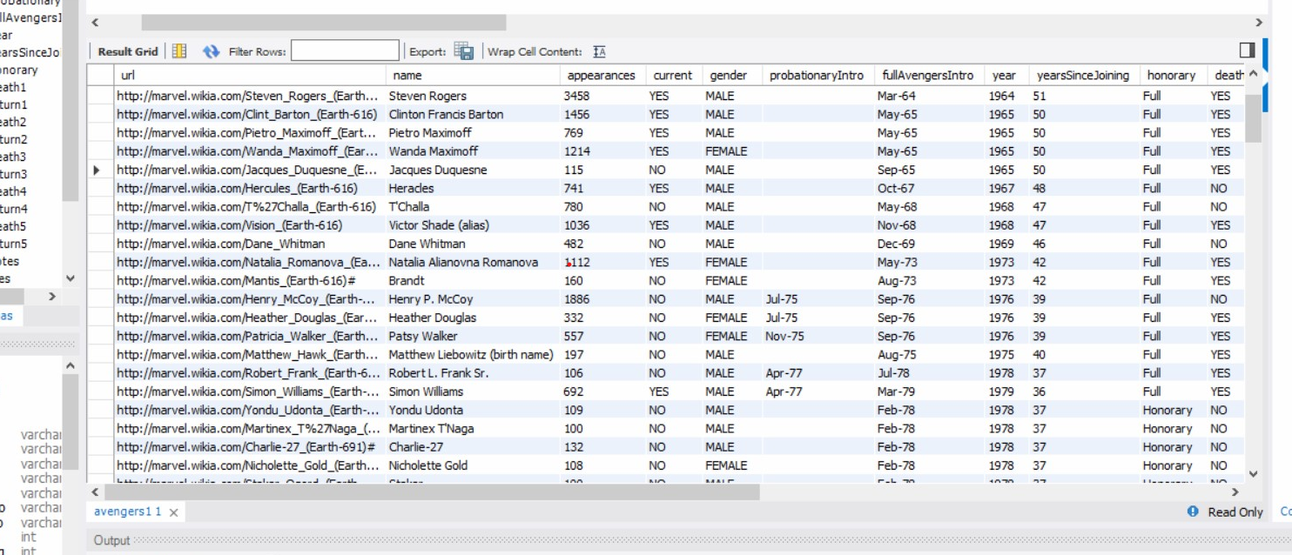

1. Create a new table with information from another super hero group [can be imported from elsewhere or fictitious]. Make sure there is an appropriate header and must be at least 30 rows.
2. Query:

CREATE TABLE IF NOT EXISTS DCHEROS (HEROS_GENDER varchar(6) DEFAULT NULL, HEROS_NAME varchar(100) DEFAULT NULL, HEROS_POWER varchar(10) DEFAULT NULL, HEROS_ID int

INSERT INTO DCHEROS (HEROS_GENDER, HEROS_NAME, HEROS_POWER)

VALUES

('Female', 'Amethyst', '4'),('Male', 'Aquaman', '6'),('Male', 'Arsenal', '5'),('Female', 'Atlanna', '7'),('Male', 'Atom', '8'),('Female', 'Batgirl', '7'),('Male', 'Batman', '10'),('Female', 'Batwoman', '10'),('Female', 'Black Canary', '9'),('Male', 'Black Lightning', '8'),('Male', 'Firestorm', '7'),('Female', 'Bumblebee', '3'),('Male', 'Green Arrow', '6'),('Male', 'Green Lantern', '2'),('Female', 'Hawkgirl', '1'),('Male', 'Hawkman', '2'),('Female', 'Huntress', '3'),('Male', 'Flash', '4'),('Female', 'Katana', '5'),('Female', 'Mera', '6'),('Male', 'Monitor', '5'),('Male', 'Nightwing', '9'),('Male', 'Plastic Man', '4'),('Female', 'Raven', '8'),('Male', 'Superman', '10'),('Female', 'Superwoman', '10'),('Female', 'Stargirl', '7'),('Male', 'Robin', '7'),('Female', 'Vixen', '10'),('Female', 'Wonder Woman', '10');**Columns:** HEROS_GENDER, HEROS_NAME, HEROS_POWER, HEROS_ID

**Expected row count:** 30

d. Screenshot

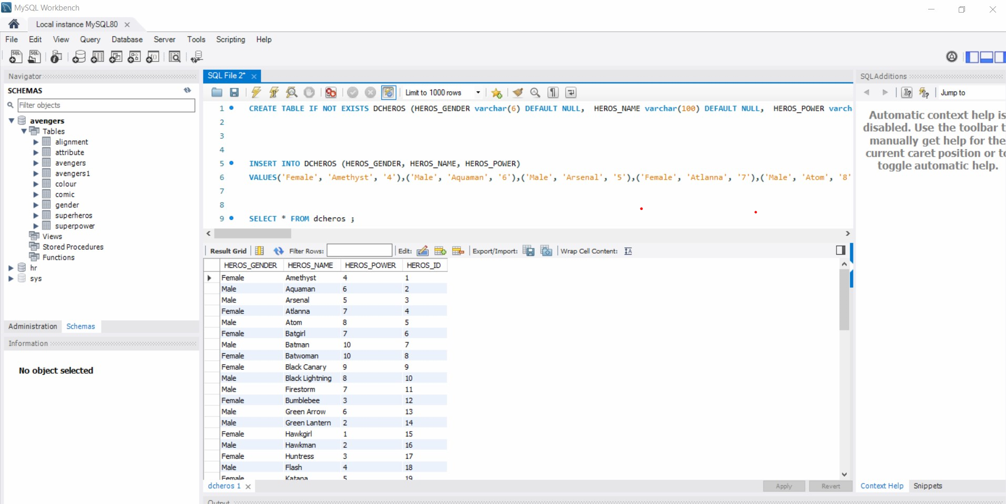

1. Add a column to your new table (let us call it the new superheros) for those who are interested in joining the Avengers. Make this be randomly assigned.  ***Hint:****it is okay for this to be a multi-step query.  You will have to use rand() function and CASE WHEN statement too.*

QUERY:

ALTER TABLE dcheros ADD new_superheros VARCHAR(6);

UPDATE dcheros SET new_superheros = (CASE WHEN (RAND()*10) > 5 THEN 'true' ELSE 'false'END);

Columns:5

*Rows:60*

*Screenshot:*

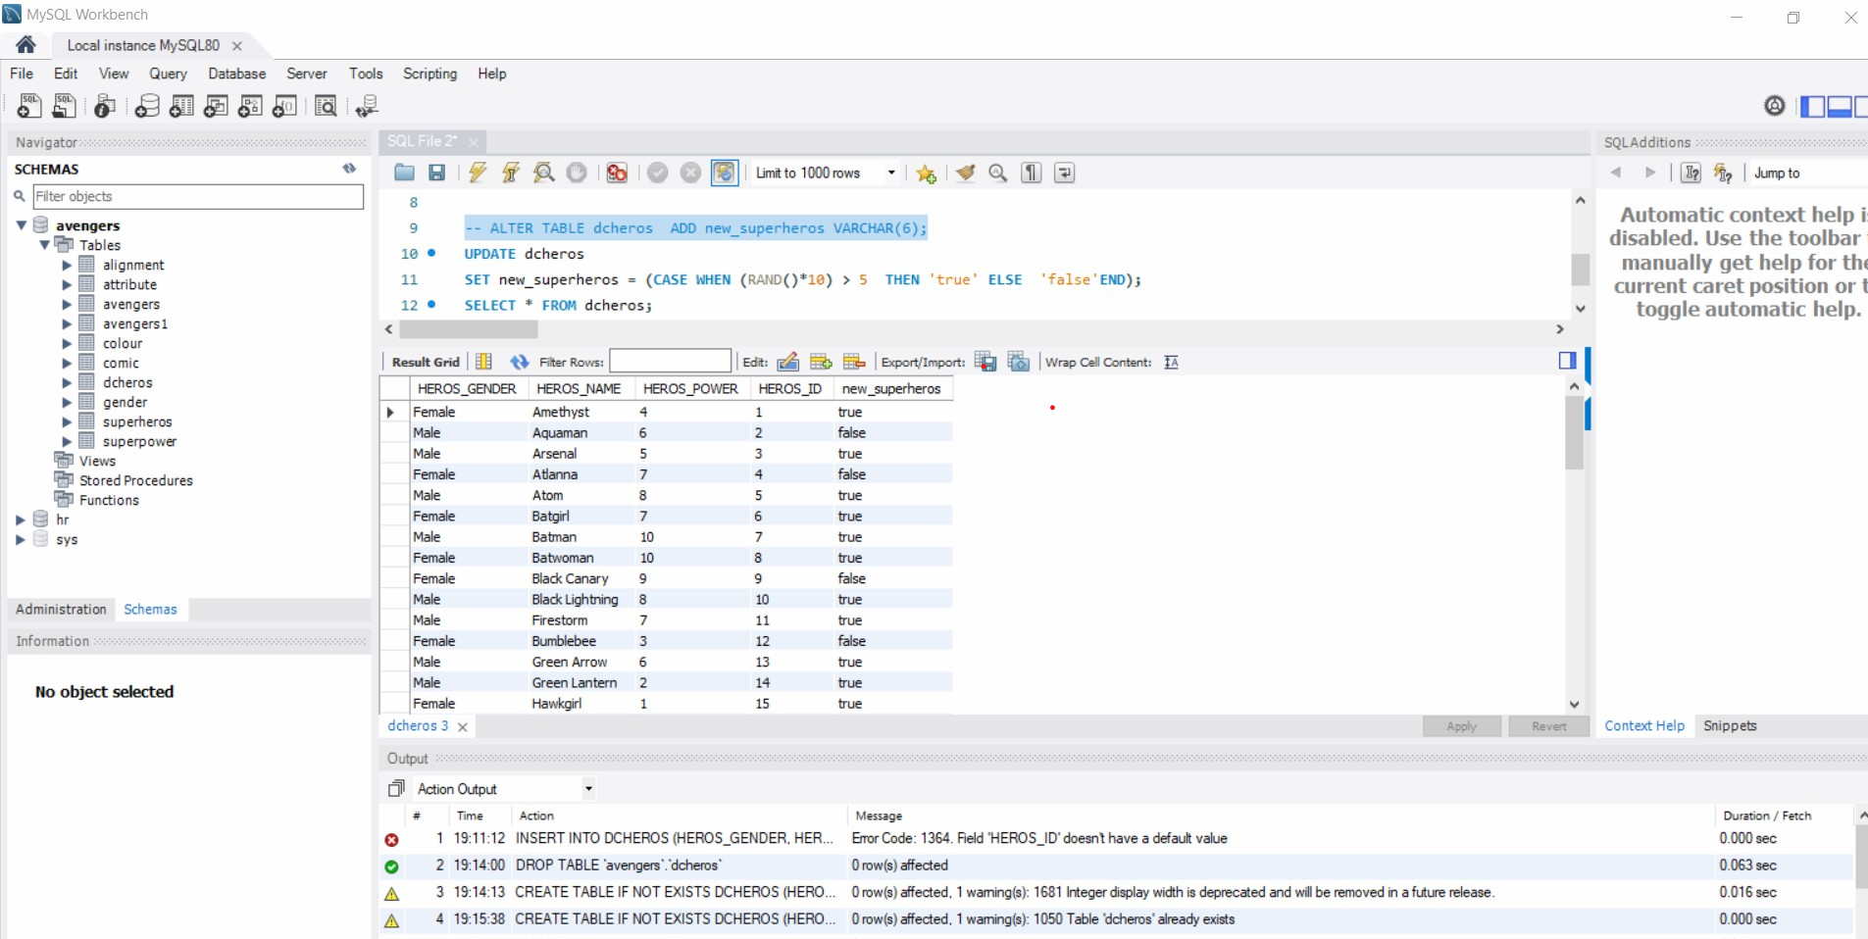

1. Add a column to your new table (the new superheros) for their favorite Avenger (have it randomly choose between Anthony Edward "Tony" Stark, Robert Bruce Banner, & Victor Shade).

Query :

ALTER TABLE dcheros ADD favorite VARCHAR(100);

UPDATE dcheros

SET favorite = (CASE WHEN (RAND()*10) > 3 THEN 'Anthony Edward "Tony" Stark' WHEN (RAND()*10) > 6 THEN 'Robert Bruce Banner' ELSE 'Victor Shade'END);

Columns 6

Screenshot:

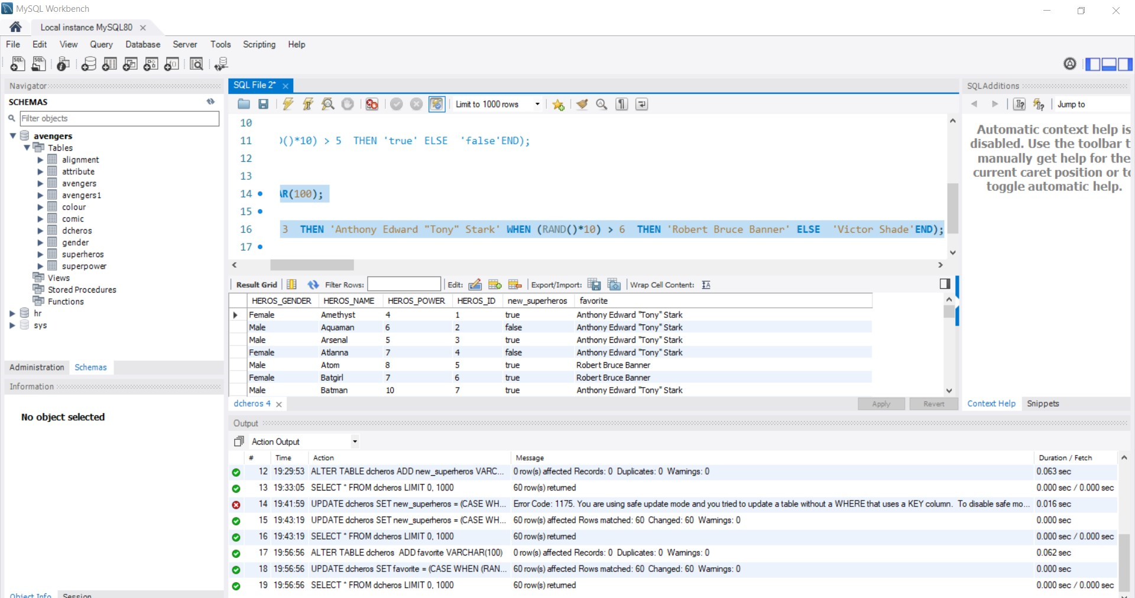

1. Use a JOIN statement between the two tables for who is interested in joining the Avengers.

Query:

USE avengers;

SELECT DISTINCT * FROM avengers

CROSS JOIN dcheros

Columns: 0

WHERE new_superheros = 'yes'

Screenshot:

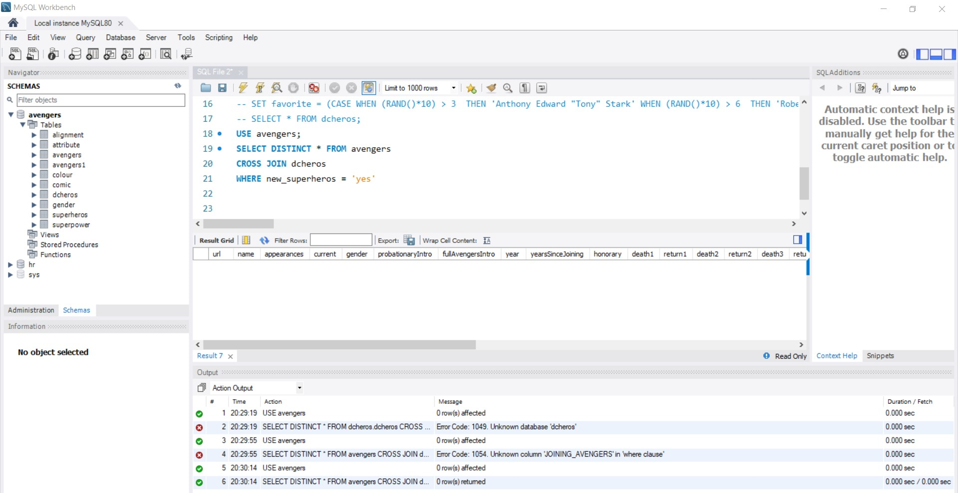

1. List all Avengers who have more than 1000 appearances in alphabetic order.

Query:

SELECT name, appearances

FROM avengers

WHERE appearances > 1000

ORDER BY name ASC;

Columns: 2

Rows:20

Screenshot:

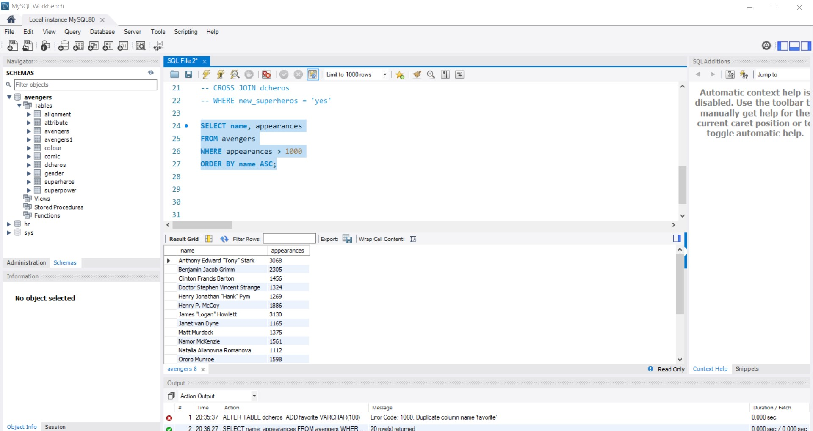

1. What Avengers do not have more than 1000 appearances?

Query:

SELECT name, appearances

FROM avengers

WHERE appearances <= 1000;

Columns: 2

Rows:151

Screenshot:

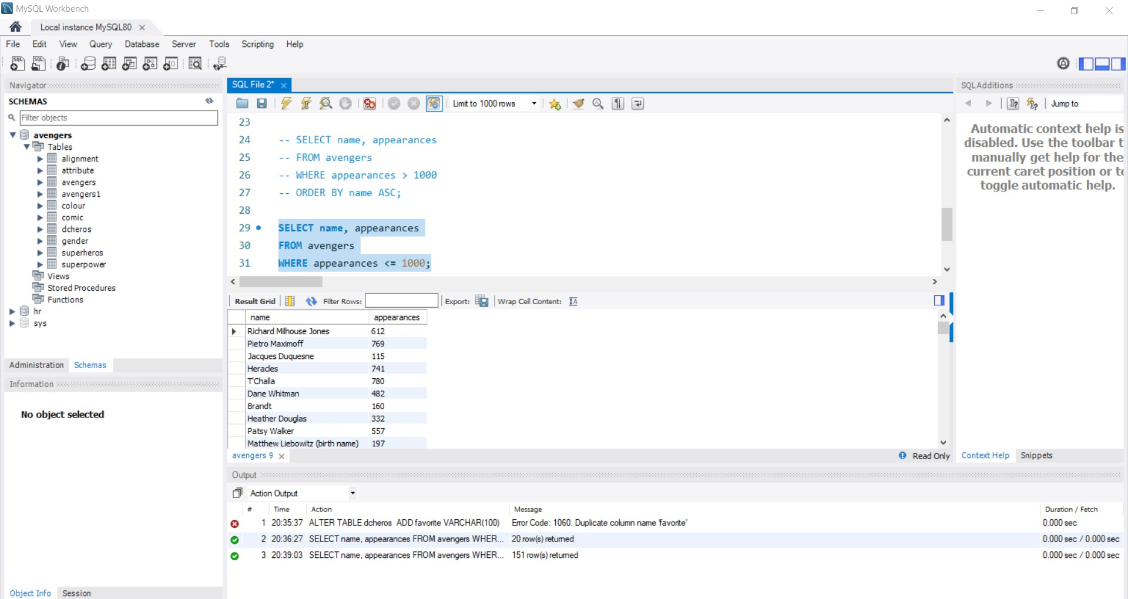

1. Not more than 500?

Query:

SELECT name, appearances

FROM avengers

WHERE appearances <= 500;

Columns : 2

Rows: 120

Screenshot:

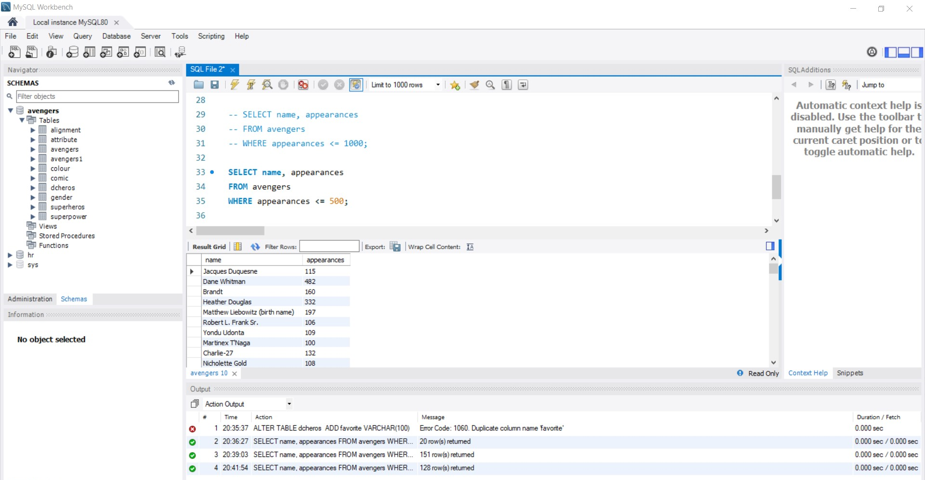

1. Not more than 50 and female?

Query:

SELECT name, appearances

FROM avengers

WHERE appearances <= 50;

Coloums :2

Rows: 41

Screenshot:

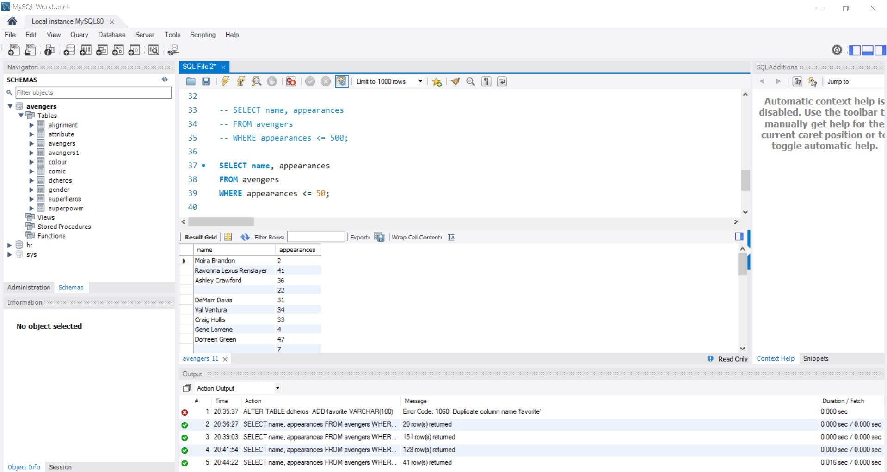

1. More than 150, male, and are full members?

Query:

SELECT name, appearances, gender, honorary

FROM avengers

WHERE appearances > 150 AND gender = 'MALE' AND honorary = 'Full';

Coloums : 4

Rows:41

Screenshot:

